PROJECT DEMONSTRATION
1. Introduction
PocketSmart AI – Your Smart Budget & Recommendation and Assistant is a simple budget management project developed to help users understand their monthly budget and expenses.
2. Demonstration Steps
Step 1: Start the Application
The user starts the PocketSmart AI application.
Step 2: Enter User Details
The user enters their name.
Step 3: Enter Monthly Budget
The user enters their monthly budget amount.
Step 4: Enter Total Expenses
The user enters the total amount spent during the month.
Step 5: View Budget Summary
The system calculates :
Monthly budget –Total expenses
Step 6: View Recommendation
The system provides a recommendation based on the remaining balance.
If the balance is positive, the user is within the budget.
If the balance is zero, the full budget has been used.
If the balance is negative, the user has exceeded the budget.
3. Sample Demonstration
Name: Madhina
Monthly Budget: ₹10,000
Total Expenses: ₹7,500
Remaining Balance: ₹2,500
Recommendation: You are within your budget. You can save ₹2,500.
4. Screenshots
PROJECT DEMONSTRATION
1. Introduction
PocketSmart AI – Your Smart Budget & Recommendation and Assistant is a simple budget management project developed to help users understand their monthly budget and expenses.
2. Demonstration Steps
Step 1: Start the Application
The user starts the PocketSmart AI application.
Step 2: Enter User Details
The user enters their name.
Step 3: Enter Monthly Budget
The user enters their monthly budget amount.
Step 4: Enter Total Expenses
The user enters the total amount spent during the month.
Step 5: View Budget Summary
The system calculates:
Remaining Balance = Monthly Budget − Total Expenses
Step 6: View Recommendation
The system provides a recommendation based on the remaining balance.
If the balance is positive, the user is within the budget.
If the balance is zero, the full budget has been used.
If the balance is negative, the user has exceeded the budget.
3. Sample Demonstration
Name: Asbiya
Monthly Budget: ₹10,000
Total Expenses: ₹7,500
Remaining Balance: ₹2,500
Recommendation: You are within your budget. You can save ₹2,500.
4. Screenshots
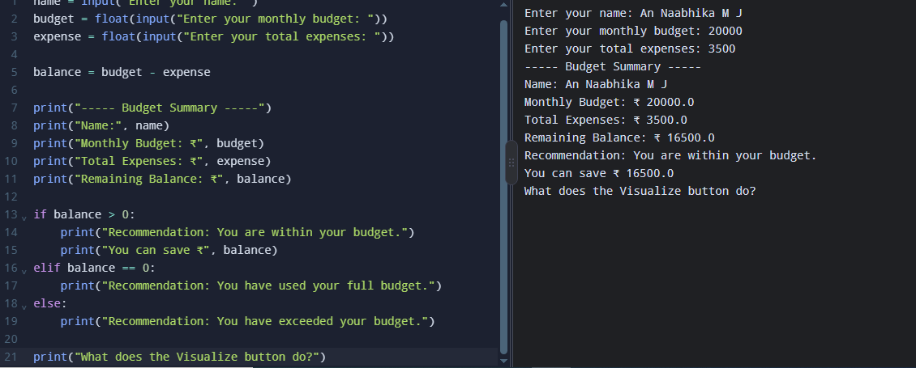
5. Demo Video
A demonstration video of the PocketSmart AI project can be provided through a shareable video link.
Demo Video Link: _https://drive.google.com/file/d/1a1fPZIOuzUH1Zy-AzpDkOtm5kWTUgK4f/view?usp=drive_link
6. Conclusion
The demonstration shows how PocketSmart AI accepts budget and expense details, calculates the remaining balance, and provides a simple budget recommendation to the user.

